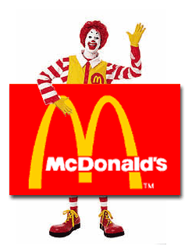

Av: _________________________________
(Josef Norlin)

McDonald’s

Introduction

I decided to write an essay about an English/American company. Many companies where flying around in my head. But then I thought that McDonald’s where a good subject because I will probably work there some day. I think McDonald’s is a really cool company because it have grown to the most famous, biggest and service-minded restaurant company in the world in a very short time.

History

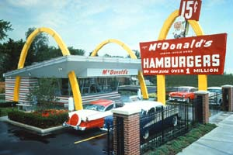
The precursor to McDonald’s was founded 1948 in San Bernardino. It was Dick and Mac McDonald that had take notice that the costumers was getting more and more stressed and used their car more often. So the McDonald brothers figured out that they should serve the food faster, serve first-class food, cleaner restaurant and drive in. And they made it! The restaurant was going better and better for each day that past by.

The Golden Arches
The famous "M" you can see around every McDonald restaurant was an idea from Dick McDonald. He wanted to have two arches with neon lights on his restaurant. (On the picture) The arches were separated, but if you look at it from the right view it looks like a big “M”. From the beginning the roof was included in the logo, but after a while they thought it look better without the roof.

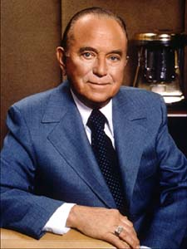
Ray Kroc
On another place in USA Ray Kroc where trying to sell his multimixer. The multimixer was a milkshake machine that could make 5 shakes at the same time. After a while he was selling so many multimixers to the McDonald brothers that he decided to come to their restaurant and see what they did with all the multimixers. When Ray entered the restaurant he was surprised that they had eight multimixers running, which means that they could make 40 milkshakes at the same time!
Ray was very impressed of everything that he had seen. And at once he saw a possibility to build more restaurants of this kind. The McDonald brothers were happy about Ray’s ideas and Ray becomes the first franchiser to McDonald’s. A franchiser is a person or a company that owns a restaurant and having it’s own economy but they are just selling the products from the mother company, in this case McDonald’s.
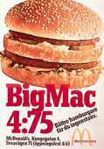
After a while Ray gets the position of VD in McDonald’s.

The birth of Big Mac™
Jim Delligatti was one of the franchisers, and his restaurant wasn’t going so good. So he figured out that if he made a hamburger that spoke more to grown-ups the business would go better. He came up with the idea with a “double burger”.
This was really good for his business and pretty soon the hamburger was for sale in the whole USA (and later in the whole world). Big Mac™ is today the most known product on McDonald’s Menu.

Ronald McDonald
Ronald McDonald is a world known clown that entertain millions of millions kids everyday all over the world. In Sweden McDonald’s have 2 persons that are employed just for acting Ronald McDonald in the restaurants in Sweden plus having different lectures in school.

McDonald’s is coming to Sweden

The man who founded McDonald’s in Sweden was Paul "Palle" Lederhausen. He worked with selling machines to different hamburger and hot-dog stands. But one day he was in USA and went to a restaurant called McDonald’s. He was very surprised of the cleanliness and all the people that were served in so short time.
Until here the history of Palle and Ray are pretty close but Palle just went back home. After some years he was invited to opening of the first McDonald’s in Europe and he just become more convinced that this concept was a real money machine.
When McDonald’s wanted to start restaurants in Sweden Palle got the job to find a good franchiser. It all ended up that he self took the job as a franchiser and become the founder of McDonald’s in Sweden. After 4 years studying a contract was written and the first McDonald restaurant in Sweden opened the 27 October 1973.

What McDonald’s is today

After 43 years in the business McDonald’s have grown to the largest restaurant chain in the world. They have around 16.000 restaurants all over the world, divided in 79 countries. Even their logotype (the golden arches) has reached success, it’s the strongest and most famous trademark in the world according intertrade. McDonald’s is also very big in Sweden, we have 212 restaurants in Sweden today and McDonald’s are planning to start 20 - 25 new restaurants every year!

How could they do it?

Saw what the people wanted
I believe that a big part of McDonald’s success is that they where quick to see what the people wanted. They didn’t want to wait for their food, they wanted a clean restaurant and that the food tasted real good. And they worked really hard to make the costumers happy.

Got the young public
McDonald’s have succeeded to reach the young public. Ronald McDonald and a little toy in every Happy Meal™ for example is a good way to get the children want to eat on McDonald’s.

Advertising
And of course all the commercials plays a big part to make McDonald’s what it is today.

Conclusion

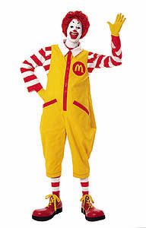
Dick and Mac McDonald was the founder of McDonald’s precursor. They created a restaurant that was cleaner and served the food faster. Ray Kroc was visiting the restaurant one day and then become a franchiser for McDonald’s. After a while Ray become the head master of McDonald’s. Jim Delligatti was the creator of the Big Mac™. The founder of McDonald’s in Sweden was Paul “Palle” Lederhausen. Today McDonald’s is the biggest restaurant chain in the world with over 16.000 restaurants in 79 countries. I believe a big part of their success was that they saw what the people wanted, succeeded to catch the young public and advertised a lot!

Sources

Internet:
www.mcdonalds.com (2001-06-08)
www.mcdonalds.se (2001-06-19)
www.online.bonnier.se (2001-06-08)
Books:
National Encyklopedin (1993)

