

Under 1800 century had Usa’s population increased quickly, 1890 was it pepolecounting in USA. But they realized that they neaded new methods, a competition organizated in Usa, who could creat the best pepolecounting tool would whin a prize.
The German imegrant Herman Hollrith won the competiotion, he created a punch card machine as used electrisity. Holleritchs machine become the ground for Tabulating Machine Company, later the company become a fusion of companies and after that the company changed name to IBM. IBM stands for “Internationall buissnes machines”.
Tre years after the fusion of companies came Thomas J watson in to the picture, he consider to be IBM father to the company, he was very successful in the company. He raised the company from nothing to world biggest computer Hardware Company.

1928 had IBM established an office in Stockholm Sweden, but 1913 could you find few some products from IBM in Sweden. Anders Thalme was employed early when IBM came to Sweden, he worked as Engineer on IBM.
He tells it was a big disadvantage whith the machines, they missed instruction and spare parts. On the nights Aders Thalme picked down the machines and whatched how the machine worked.

Alredy in 1936 IBM launched first electrical typewritemachine.
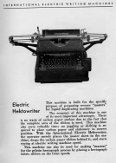IBM’s first electrical typewrite machine.

1944 was Mark 1 ready for production as was named IBM’s first computere. But really it was a calculator; it took 6-second to multipiclate 2 23 figuresnumbers for the machine!!
An early invention as raised IBM was 701, was very popula around the world, 701 could carry out 17 000 comandos each second.

Under 60-70 was the computers resemble in our days, example Ramac 305 have a magnetical Harddisk, and the hardware could you uppgrade, and seven years later could you buy a floppy disk station to the computer.

1981 was it a “Revolution”, IBM launched PC (Personal computer) and it was a succes around the world. Personal computer created a “standart” for how the computers of today think (not Mac). IBM PC had 16 kb space, and 2 floppy disk station, OS was DOS, and when you bought the pc you got a printer as could print black and whithe, the printer couldn’t print pictures or something like that...
And it was first time IBM bought componets from other companys instead to manifact them selfs, they bought the Processor from Intel and the OS was named DOS bought they from a small company named Microsoft. As you know is Microsoft world biggest company thank as IBM!!
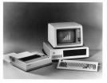 This is a Personal Computer from 1981.

1993 had IBM 383 000 employers worldwide and did a record loss about $8 billion Dollars, but IBM did hard savings and they turned the record loss to profit.
Now the IBM have 269 000 employers worldwide.
IBM is now world famouse company, and biggest computer hardware company.

In the 90’s IBM tried to built a super computere as only could play chess, the mean whith this project was to defend world best chess player Garry Kasparov from Russia.
1990 was the Computer ready, Garry kasparov won the match very easy.
7 years later wanted IBM have a revanch againts kasparov, they employed chess experts and they construkted “Deep blue” costed for IBM $5 milion dollar, Deep blue could analyzis 200 000 000 chess moves each second and weight over 2 tons, and Kasparov could analyliz about 15 chess moves whith his brain each second! 1997 was the machine ready to compete againts kasparov, in 1997 12 may meted Deep blue Kasparov in NY, Deep blue won, match status was to Deep blue 2.5-3.5.

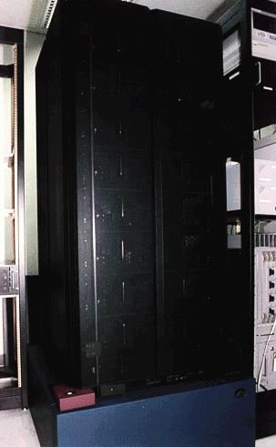 This is Deep blue, a gigantic computer.

IBM is now looking forward to the fusion, they are selling & devolop lot of things right now, example: advance servers, PC’s, Hard drive as can save over 120 gb, and advance chipses as they sell to other companys and much more….

This is IBM lastest products:

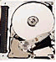This is world compact&and smallest hard-drive, this harddrive is on the sam size as our swedish 5 krona coin!! And have space on 1 GB.

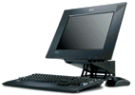This is Ibm lastest pc, the pc is made for small homes and offices as not have so much space to use.

END

Robin 8b Gävle

Bibliography:

www.ibm.com

Focus 2000

PC för alla nr: 1 Februari 2002.

http://www.research.ibm.com/deepblue/home/html/b.html

VG

